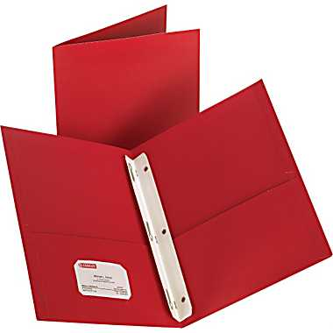
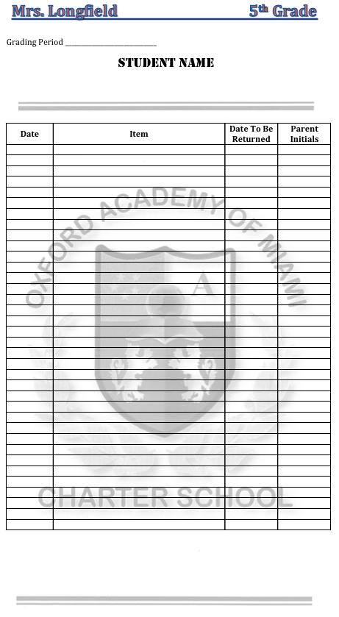

The purpose of the Friday Folder is to have a method of communication between the school and the parent. Most information is posted online, but often materials must be sent home. Materials often do not reach the parent’s hands.

There are 3 important components for this folder.
- It is RED. Each of my classes will be identified by a color and Fifth Grade will be RED. This allows for quick recognition and location.
- It must have 2 pockets and 3 prongs.
- It must include at least 25 blank pieces of lined paper in the back pocket, as well as 25 sheets inserted into the prongs.

The first pages of the pages inserted in the prongs will be copies of the Parent Signature form. These will be supplied and extras will be available. It will also be posted on my website for you to download and print if needed. A list of the items to be included will be posted on the board weekly. This list will be copied by the student onto the Parent Signature sheet

To be inserted in prongs IN THIS ORDER:
- Parent Signature Forms
- School Calendar
- Class Schedule
- 25 Sheets of Lined Notebook paper.

The folder will be taken home on Friday, parents will review materials and each item initialed. The folder will be returned on Monday. A non-returned folder will mean notification of parents by written note, email or phone. Parents are welcome to send any items, concerns or questions to me by way of the Friday Folder.

Each student will be provided with a folder in the first week. If the folder is lost or damaged, it is the student’s responsibility to replace it.

